A Report on

**Arduino Based Project**

Titled

**Automatic Room light control**

for

**Mini Project 1B (REV- 2019 ‘C’ Scheme) of Second Year, (SE Sem-IV)**

in

**Electronics & Telecommunication Engineering**

by

1. A-56. Vipul Sudhakar Bhoge
2. A-57. Divya Surendra Salvi
3. A-59. Gayatri Govind Shinde
4. A-60. Pranay Ramchandra Bedekar

Under the guidance of

**Prof. Ishmeet Singh Riar**



**UNIVERSITY OF MUMBAI**

**A. Y. 2020-21**

|  |  |
| --- | --- |
| 3DBB23F3 | **Mahatma Education Society’s**  **Pillai College of Engineering**  **Accredited A+ by NAAC**  **Dr. K. M. Vasudevan Pillai Campus,**  **Plot No. 10, Sector-16, New Panvel - 410206** |

**CERTIFICATE**

This is to certify that the **Arduino Based Project** entitled **Automatic Room Light Controller** is a bonafide work of

1. A-56. Vipul Sudhakar Bhoge
2. A-57. Divya Surendra Salvi
3. A-59. Gayatri Govind Shinde
4. A-60. Pranay Ramchandra Bedekar

submitted to the University of Mumbai in partial fulfillment of the requirement for the award of **Mini Project 1B (REV- 2019 ‘C’ Scheme) of Second Year, (SE Sem-IV)** in **Electronics & Telecommunication Engineering** as laid down by **University of Mumbai** during academic year **2020-21**

|  |  |
| --- | --- |
| (_____________________) | (_____________________) |
| **Examiner/Reviewer-1** | **Examiner/ Reviewer -2** |

|  |  |  |
| --- | --- | --- |
|  |  |  |
| **Prof. Ishmeet Singh Riar** | **Dr. Avinash Vaidya** | **Dr. Sandeep Joshi** |
| **Guide** | **Head of Department** | **Principal** |

**ABSTRACT**

It can be used to turn ON and OFF the lighting system of home automatically by detecting the presence of human. This system can be used in garages, classrooms, staircases, bathrooms, etc. where there is no need of continuous light but only when there is a human. Also, there is no need to worry about electricity bills as the lights get OFF when there is no human and hence one need to pay the bills as per use. The main components used in this system are Arduino Uno, PIR and Relay Module. Out of these components, the operation of system mainly depends on PIR sensor which helps in detecting human presence.**LIST OF FIGURES**

|  |  |  |
| --- | --- | --- |
| **Figure No.** | **Name of the figure** | **Page No.** |
| 4.1 | Block Diagram Of The Automatic Room Light Controller. | 5 |
| 4.2 | Circuit Diagram Of The Automatic Room Light Controller. | 6 |
| 5.1 | Arduino Uno. | 8 |
| 5.2 | IR Sensor | 9 |
| 5.3 | LCD 16*2 | 9 |
| 5.4 | Relay | 10 |
| 6.1 | Diagram of automatic room light controller no one in room | 12 |
| 6.2 | Diagram of Automatic room light controller enter person in room | 13 |
| 7.1 | Diagram of Automatic room light controller no one enter in room | 14 |
| 7.2 | Diagram of Automatic room light controller two person enter in room | 14 |
| 7.3 | Diagram of Automatic room light controller exits persons in room | 15 |

**LIST OF TABLES**

|  |  |  |
| --- | --- | --- |
| **Table**  **No.** | **Table Title** | **Page No.** |
| 5.1 | List of Hardware Components. | 7 |
|  |  |  |

**LIST OF ABBREVIATIONS**

|  |  |
| --- | --- |
| IR | Infrared |
| LED | Light emitting diode |
| LCD | Light crystal display |

**LIST OF SYMBOLS**

|  |  |
| --- | --- |
| Ω | Ohms |

**INDEX**

|  |  |  |  |  |
| --- | --- | --- | --- | --- |
| **CONTENTS** | | | | |
| Certificate | | …………………………………………………………………... | | I |
| Abstract | | …………………………………………………………………... | | Ii |
| List of Figures | | …………………………………………………………………... | | Iii |
| List of Tables | | …………………………………………………………………... | | Iv |
| Abbreviation | | …………………………………………………………………... | | V |
| List of Symbols | | …………………………………………………………………... | | Vi |
|  | |  | |  |
| 1. | Introduction ………………………………………………………………….  1.1 Basics of Automatic Room Light Controller.  1.2 Automatic Room Light Controller. | | | 1 |
| 2. | Literature Review……………………………………………………………. | | | 2 |
| 3. | Problem Statement …………………………………………………………..  3.1 Need  3.2 Objectives | | | 3 |
| 4. | Principle and Working ………………………………………………………  4.1 Block diagram  4.2 Circuit diagram | | | 4 |
| 5. | Component Description ……………………………………………………..  5.1 Hardware  5.2 Software | | | 7 |
| 6. | Software Implementation …………………………………………………… | | | 12 |
| 7. | Simulation Results ………………………………………………………….. | | | 14 |
| 8. | Conclusions …………………………………………………………………. | | | 16 |
| 9. | Future Scope ………………………………………………………………... | | | 17 |
| References | | | …………………………………………………………………... | 18 |
| Appendix | | | …………………………………………………………………... | 19 |

**CHAPTER 1.**

**INTRODUCTION**

Scientific discoveries delivered us luxury and comforts. Technology has become vital and essential part of our lives. Tremendous advancement in technology is succeeded in last few years. Electrical energy has become an crucial part of human life. In recent years the people are looking forward for the automation in their day to day life, and even now the people are excited to save energy consumed to reduce the expenditures. People are becoming lazy to switch off the lights while leaving the room, so the large amount of energy is wasted if the light is remain ON in the absence of human being. Generally, in public and private sector companies, offices, school and colleges most of the people are not interested to switch OFF the electronic machines like fan, light, etc., while going out of the room

As more and more consumer electronic and home appliances are used, the size of them is becoming large; power consumption in home area tends to grow. Moreover, unusable power consumption occurs in the absence of human being in public and private sectors.

Using the automation in switching the home or office lighting system, the consumption of electricity can be comprehensively reduce which will in turn save the money of the owner. Now the people are looking forward for automation in their daily life. The people are trying to reduce human efforts.

* 1. **Basics of Automatic Room Light Controller.**

Wastage of electricity is one of the main problems which we are facing nowadays. In our home, school, colleges or industry we see that fan/lights are kept on even if there is nobody in the room or area/passage. This happens due to negligence or because we forgot to turn lights off or when we are in a hurry. To avoid all such situations we have designed this project called “Automatic room light”.

* 1. **Automatic Room Light Controller.**

The Automatic Room Lights using Arduino and PIR Sensor is a simple project, where the lights in the room will automatically turn on upon detecting a human motion and stay turned on until the person has left or there is no motion.

**CHAPTER 2.**

**LITERATURE REVIEW**

There are several journal papers that have been published based on the smart lighting. Efforts are made to improve the current approaches for the lighting system for better efficiency and low power consumption with hybrid approach. Richu Sam Alex et al. proposed a system which reduces the power consumption of the street lighting system about 30% compared to conventional design. This system is fully automated. It also uses arduino so that control station can also analyze all the performances of the system.

Daeho Kim et al. worked on smart LED lighting system by using Infrared and Ultrasonic sensors together. Here they proposed a model which continuously tracks the human motion. Output based on the human tracking data which is obtained by these sensors are responsible for determining the On-Off control of the LED lighting. Previously existing system fails in continuously monitoring the motion of an object by using each sensors separately. For the same reason, the efficiency of the existing system is low. By the hardware implementation they developed a model to improve the efficiency which helps in smart lighting. The proposed approach make use of sensors in which IR sensor sends the sensed data to the MCU board which in turn sends the same data to the LED control layer. Depending on the results of the sensed data LED control layer turns on the lighting system. Human presence is detected by IR sensor and continuous tracking is possible by the Ultrasonic (US) sensor. As before the sensed values are sent to the MCU board by US sensor which controls the On-Off of the lighting. US-IR positioning based system has to be studied in future.

**CHAPTER 3.**

**PROBLEM STATEMENT**

Electricity is one of the most important resources in this country. The electricity must be conserved. But many times people come outside the room/hall forgetting to turn off the lights, thus the electricity is wasted.

* 1. **NEED**

The concept behind this project is to cut power supply when there is no one in the room, thus reducing energy consumption Ensure the saving of electrical energy.

* 1. **OBJECTIVES**

The ultimate objective of this system is to save the energy as well as to design automatic room light controller by turning off all the appliances when nobody is there in the home. This system possesses two sets of IR LED and IR sensors to detect the persons entering and leaving the room.

**CHAPTER 4.**

**PRINCIPLE AND WORKING**

The IR sensor continuously senses the presence of any obstacles (a person in our case). If sensor 1 senses a person, it informs the controller that a person has entered so that controller can increment the count. At the same time it gives a delay of 1sec so that the person can cross the sensor 2 and the count is maintained correctly. When a person exits, the sensor 2 informs the controller to decrement the count. Similarly it also provides a delay of 1 sec to maintain count properly. The count is displayed on LCD by the controller. If there is at least 1 person is inside the hall, an LED will glow otherwise it is off.

**4.1 BLOCK DIAGRAM**

This block diagram showing that the arduino is the heart of this project. Arduino uno perform all the operation using IR sensor and display the person entering in room as well as exiting in room. Then which condition has satisfied when the light will turn on and off

Power Supply

LCD Display

IR Sensor 01

ARDUINO

UNO

IR Sensor 02

Relay

Bulb

**Figure 4.1- Block Diagram of the Automatic Room Light Controller**.

**4.2 CIRCUIT DIAGRAM**

In the given circuit diagram, we are using the 1 arduino uno, 2 IR sensors which is used for detect the person, LCD is used display count. Relay used for switching purpose and bulb whenever satisfied condition then the light will turn on and off.

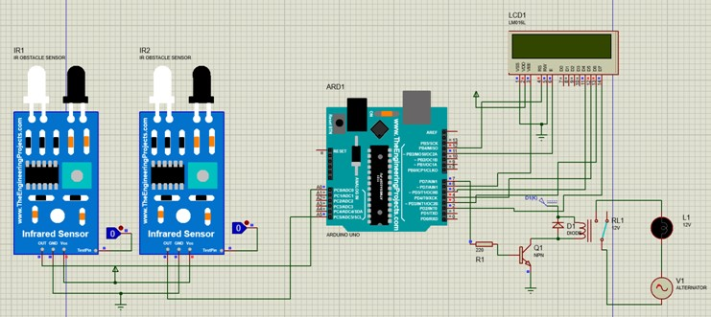

**Figure 4.2- Circuit Diagram of the Automatic Room Light Controller CHAPTER 5.**

**COMPONENT DESCRIPTION**

This chapter deals with the components used in this project.

* 1. **HARDWARE**

This is the list of Hardware components used to simulate this project.

**Table 5.1 List of Hardware Components**

|  |  |
| --- | --- |
| **NAME OF THE COMPONENTS** | **QUANTITY** |
| Arduino Uno | 1 |
| IR sensor | 2 |
| LCD module 16*2 | 1 |
| Relay | 1 |
| Transistor | 1 |
| Bulb | 1 |
| Resistor | 1 |

**ARDUINO UNO**

It is an open-source microcontroller based computing platform based on easy to programming and synchronizing of different analog and digital sensors and it is also capable of sending and receiving data over the internet. It is built up with 8-bit Atmel AVR or 32- bit Atmel ARM microcontrollers. It provides a comfortable design platform for hobbyists, students and professional designers. Figure 5.1 shows the ARDUINO UNO pin out.

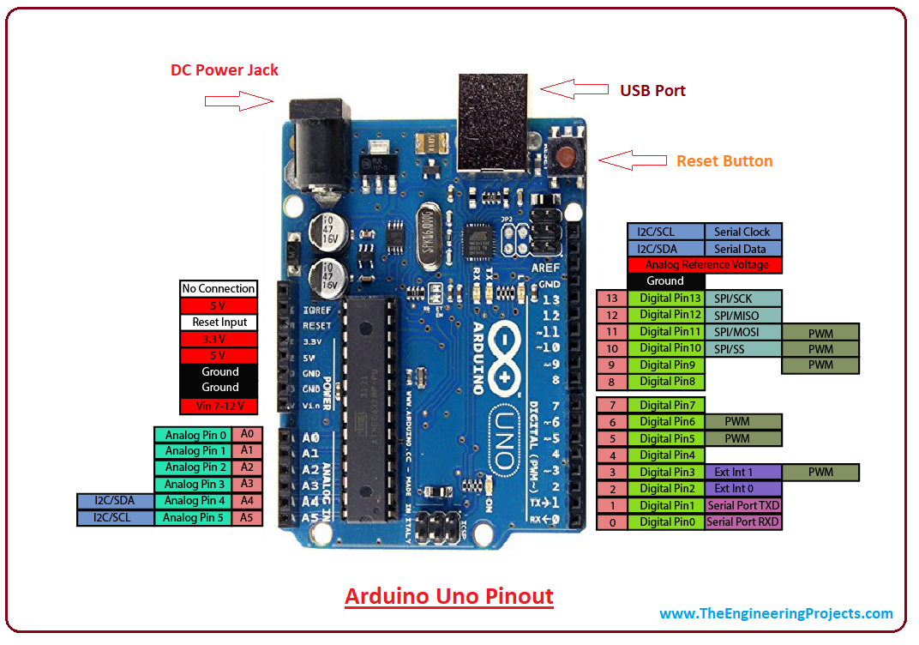

**Figure 5.1-ARDUINO UNO**

**IR sensor**

IR sensor is an electronic device that emits the light in order to sense some object of the surroundings. An **IR sensor** can measure the heat of an object as well as detects the motion. Usually, in the infrared spectrum, all the objects radiate some form of thermal radiation. These types of radiations are invisible to our eyes, but infrared sensor can detect these radiations.

The emitter is simply an IR LED and the detector is simply an IR photodiode .Photodiode is sensitive to IR light of the same wavelength which is emitted by the IR LED. When IR light falls on the photodiode, the resistances and the output voltages will change in proportion to the magnitude of the IR light received.

There are five basic elements used in a typical infrared detection system: an infrared source, a transmission medium, optical component, infrared detectors or receivers and signal processing. Infrared lasers and Infrared LED’s of specific wavelength used as infrared sources.

The three main types of media used for infrared transmission are vacuum, atmosphere and optical fibers. Optical components are used to focus the infrared radiation or to limit the spectral response.

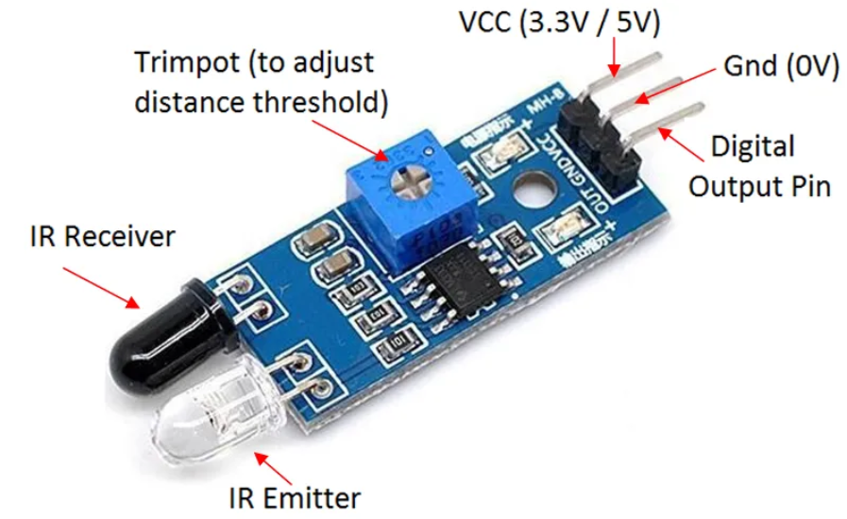

**Figure 5.2-IR Sensor**

**LCD module**

It is a liquid crystal display module. It produces visible displays. It has 16 columns and 2 rows. Each character is displayed in 5 × 7 pixel matrix. 250 k ohm potentiometer is used to maintain the contract of the display.220 ohm resistor is attached in anode terminal .figure shows a LCD 16*2.

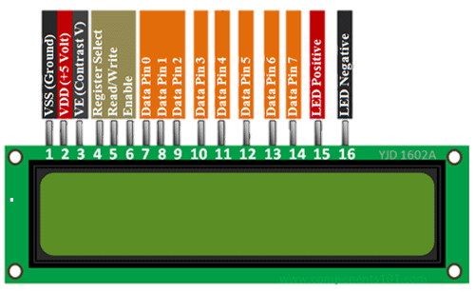

**Figure 5.3-LCD 16*2**

**Relay**

The relay is the device that opens or closes the contacts to cause the operation of the other electric control. It detects the intolerable or undesirable condition with an assigned area and gives the commands to the circuit breaker to disconnect the affected area. Thus protects the system from damage.

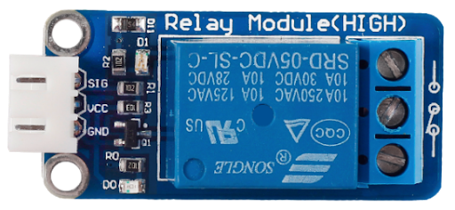

**Figure 5.4-Relay**

* 1. **SOFTWARE**

**Proteus-** Proteus 8 Professional is software which can be used to draw schematics, PCB layout, and code and even simulate the schematic. It is developed by Lab center Electronic Ltd. Drawing the schematic is very easy using Proteus. You can click the "Pick devices" button and select the desired component. You can draw wires by clicking on the terminal of the component or Vcc, Ground, etc.



**CHAPTER 6.**

**SOFTWARE IMPLEMENTATION**

This chapter deals with the software implementation part

Fig 6.1 shows that the no one in room.



**Fig 6.1- Diagram of automatic room light controller no one in room**

Fig 6.2- shows that the person enter in room

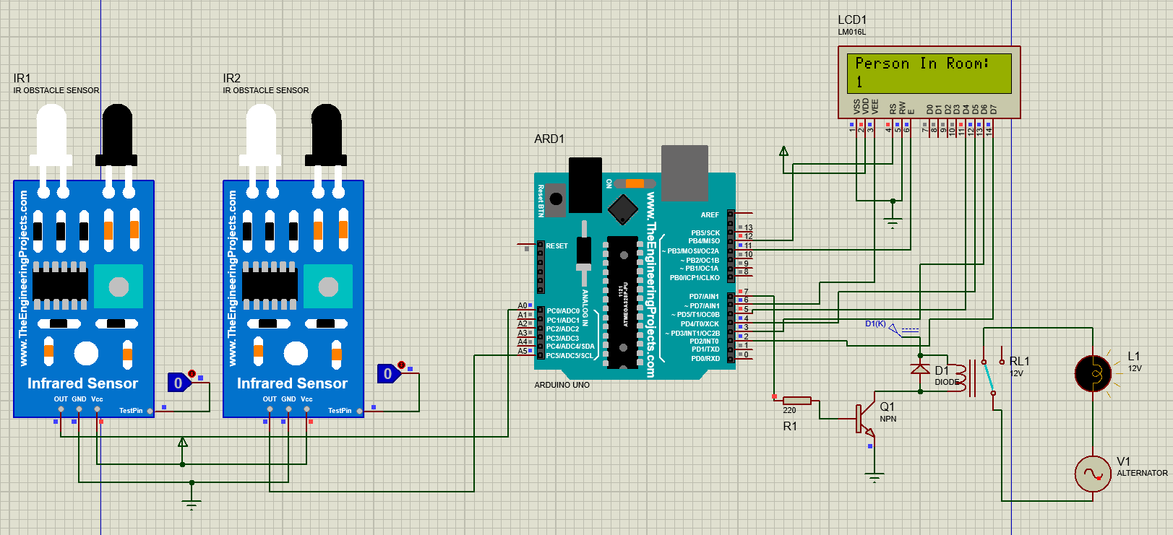

**Fig 6.2- Diagram of Automatic room light controller enter person in room**

**CHAPTER 7.**

**SIMULATION RESULTS**

Case 1: no one enter in room



**Figure 7.1 Diagram of Automatic room light controller no one enter in room**

Case 2: 2 person enter in a room



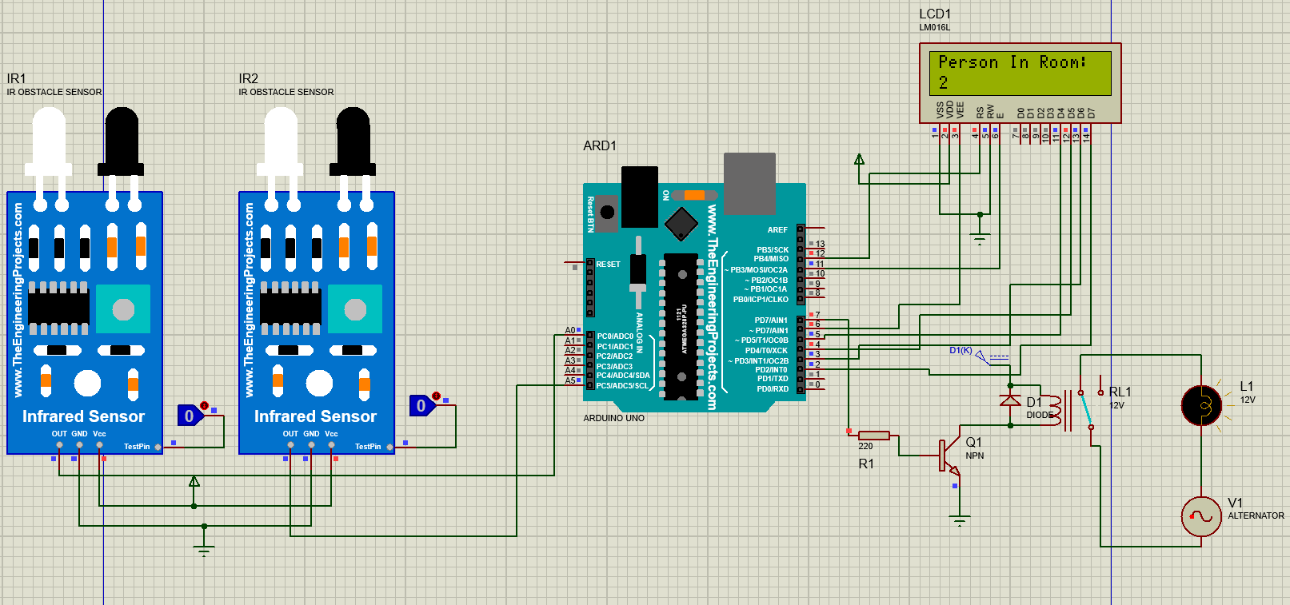

**Figure 7.2 Diagram of Automatic room light controller two person enter in room**

Case 3: everyone exit in a room

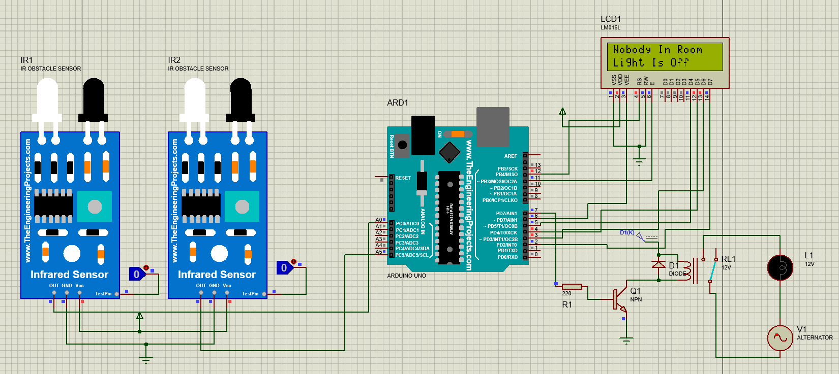

**Figure 7.3 Diagram of Automatic room light controller exit persons in room**

**CHAPTER 8.**

**CONCLUSIONS**

This chapter concludes the end results of the circuit

This project gives us an idea to detect the motion. This project can be used anywhere either at home or offices. It is very much cost efficient and can be used easily and efficiently. This system is designed using various devices like IR sensor, Arduino, relay, DC power supply and various electronic component like transistor, diode etc. The proposed system avoid unnecessary energy consumption and helps in energy saving.

**CHAPTER 9.**

**FUTURE SCOPE**

This chapter tells us about the innovations which can be done using this model.

* By using this circuit and proper power supply we can implement various applications such as fans, tube light, etc.
* By modifying this circuit and using two relays we can achieve a task of opening the door.

**REFERENCES**

1. Richu Sam Alex, R Narciss Starbell “Energy efficient Intelligent Street Lighting System using Sensors”, International Journal of Engineering and Advanced Technology (IJEAT), Vol-3, Issue 4, April 2014
2. Daeho Kim, Junghoon Lee, Yeongmin Jang and Jaesang Cha. “Smart LED lighting system implementation using Human tracking US/IR sensor” 2011 IEEE (ICTC 2011).
3. www.arduino.cc
4. http://circuitdigest.com/microcontroller-projects/automatic-room-light-controller-with- bidirectional-visitor-counter-using-arduino
5. https://create.arduino.cc/projecthub/amrendra-sahni/automatic-room-light-controller-with-bidirectional-visitor-adb0bb

**APPENDIX**

